Q: How to connect to a wireless network from Windows Vista?

A:
1) Click on the Windows Logo, then on Control Panel in the menu.
2) Click on Network and Sharing Center.
3) Click on Set up a connection or network.
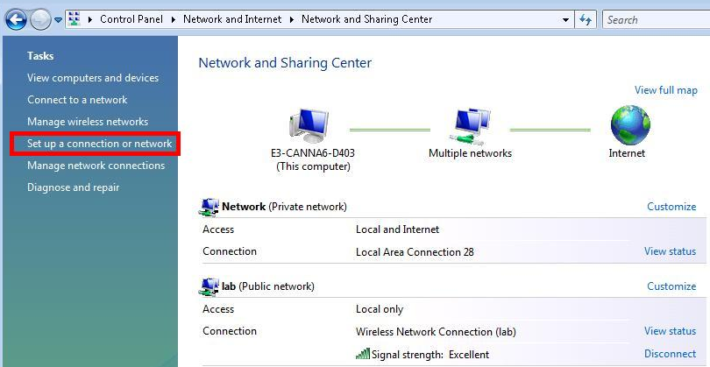
4) Select the option Connect to Internet.
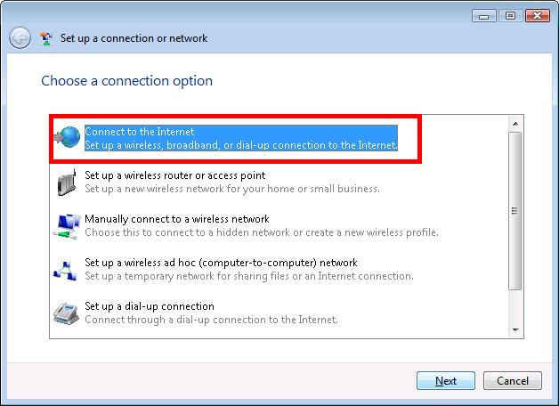
5) If this screen appears, click Set up a new connection anyway.
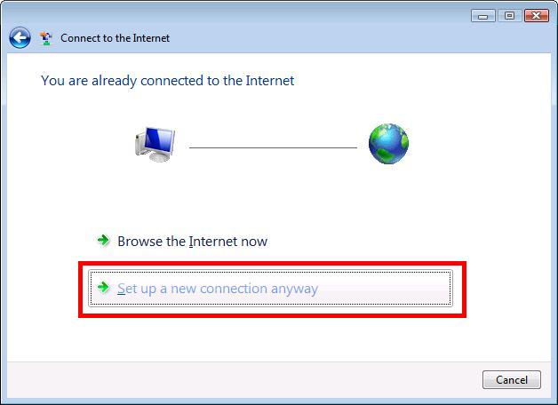
6) Select Wireless.
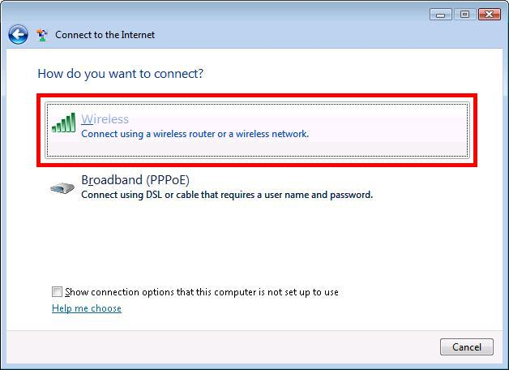
7) A list of wireless networks within range will be displayed. Click on the network that you wish to connect to, and enter the wireless security key for that network when prompted. In the example, the PC has successfully connected to the wireless network "lab".
